Assignment – 16.1
2303A510F9
BATCH:30
Task 1 – Student Information System Schema
PROMPT :
--create tables Students, Courses, Enrollments, primary keys, foreign keys, and relationships CODE AND OUTPUT :
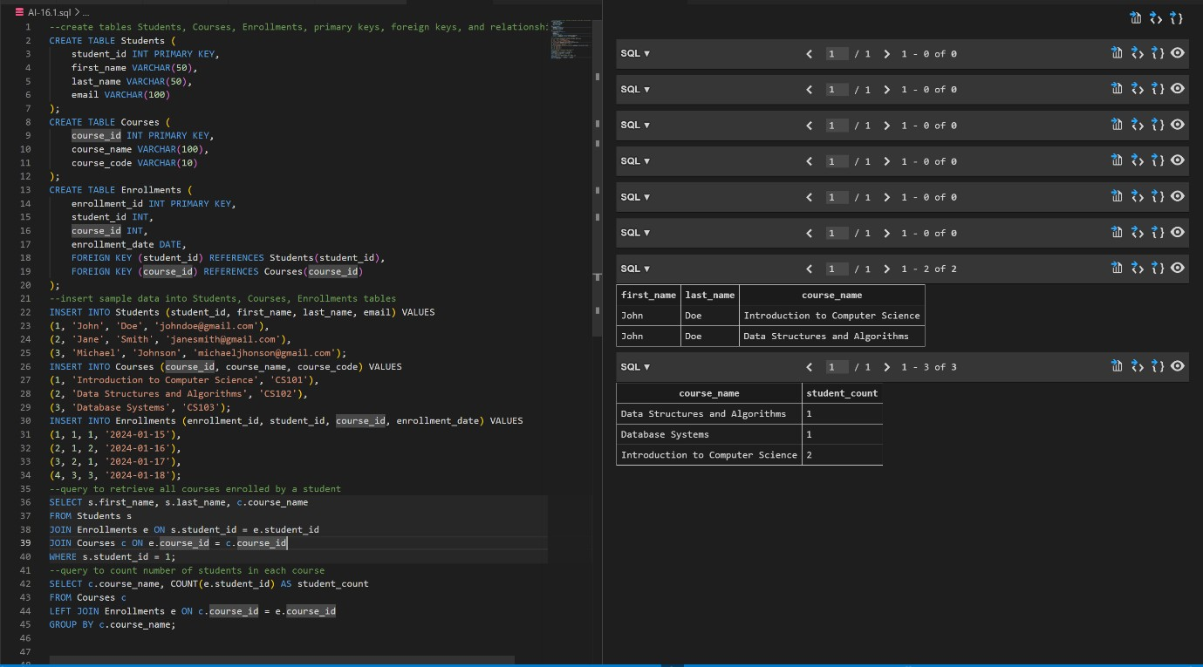
JUSTIFICATION :
This task helped me understand how student and course data are stored in a database. I learned how to connect tables using primary key and foreign key. It also improved my knowledge of writing SQL queries to get useful information.
Task 2 – Hospital Management Database
PROMPT :
--create tables doctors, patients, appointments, define consstraints(unique IDs,valid dates)
CODE AND OUTPUT :
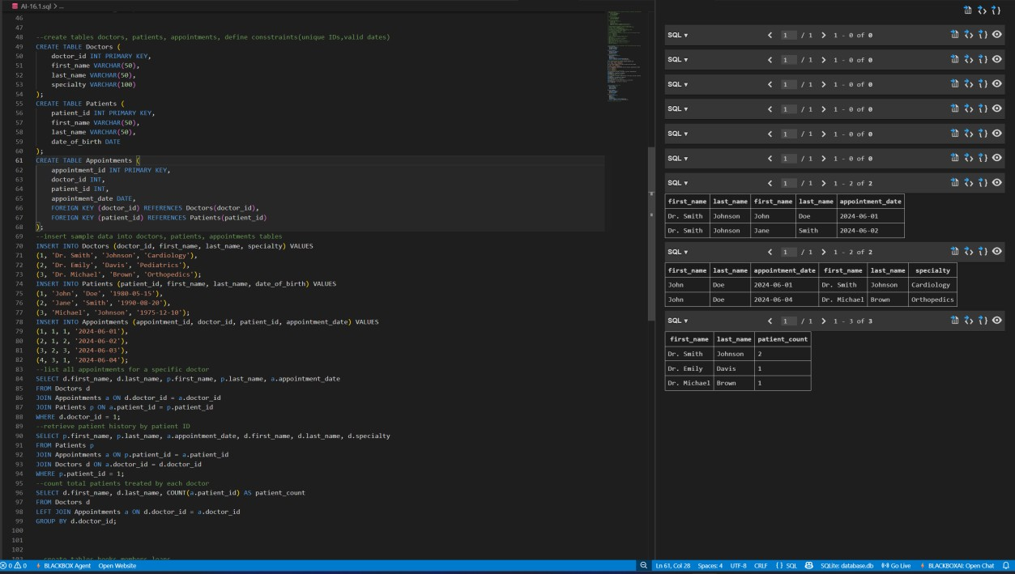
JUSTIFICATION :
In this task, I understood how databases are used in hospitals to manage doctors, patients, and appointments. I learned about using constraints to avoid wrong data. It also helped me practice queries for real-life situations.

Task 3 – Library Database
PROMPT :
--create tables books,members,loans
CODE AND OUTPUT :
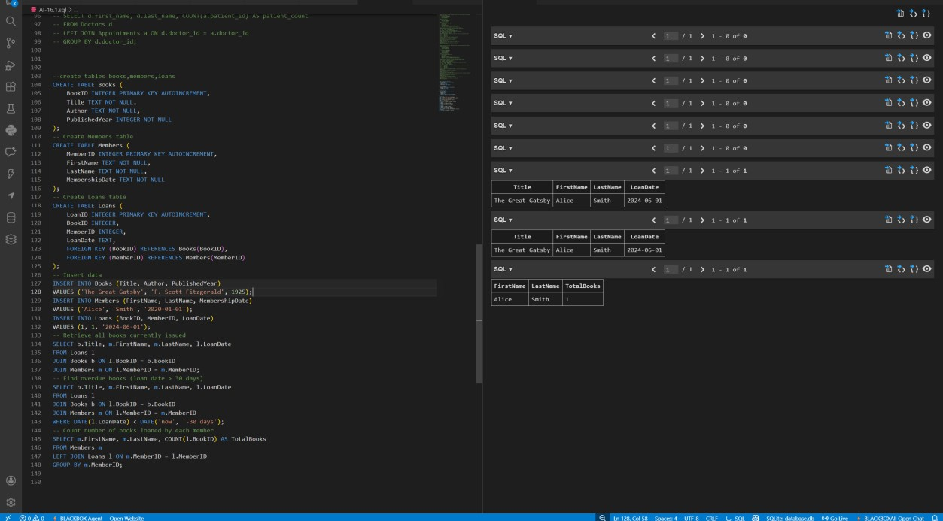
JUSTIFICATION :
This task helped me learn how a library system works using a database. I understood how to track books and members. I also learned how indexing improves performance and how to find overdue books using queries.
Task 4 – Real-Time Application: Online Shopping Database
PROMPT :
--create tables Users, Products, Orders, OrderDetails.
CODE AND OUTPUT :
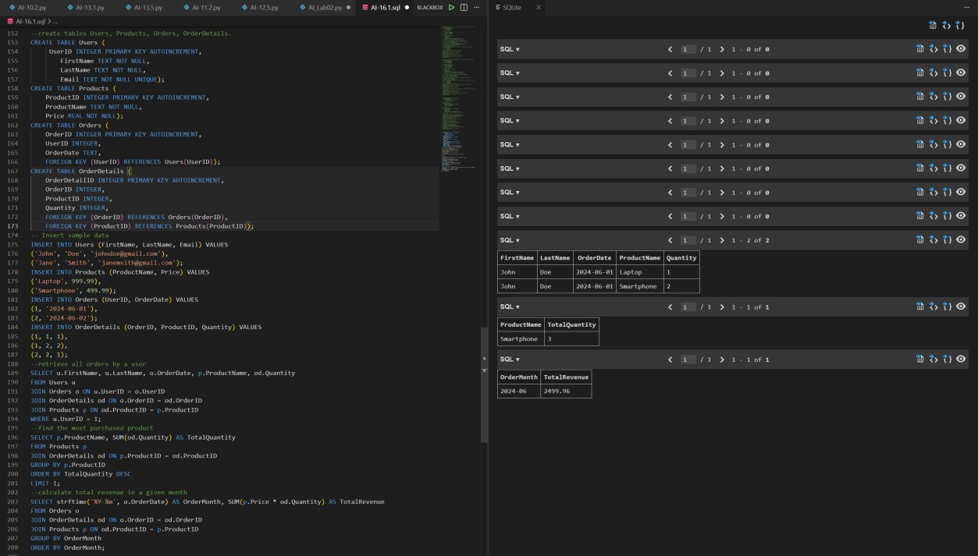
JUSTIFICATION :
This task gave me an idea about how e-commerce websites store data. I learned how different tables like users, products, and orders are connected. Writing queries like total revenue helped me understand business analysis.
Task 5 – University Examination Database
PROMPT :
--create tables Student,Subjects,Exams,Results.primary keys, foreign keys, referential integrity constraints
CODE AND OUTPUT :
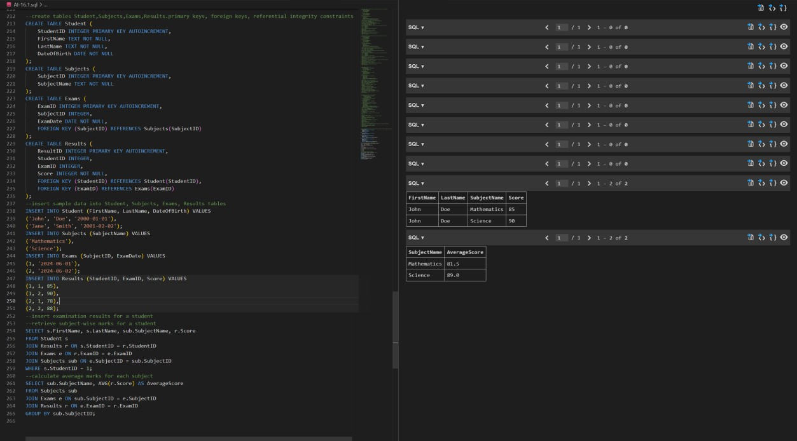
JUSTIFICATION :
This task helped me understand how exam data is managed. I learned how to store marks and calculate averages using SQL. It also improved my skills in using joins and aggregation functions.

